**Assignment 5**

1. Design and implement a class named InstanceCounter to track and count the number of instances created from this class.

Code :-

**package** project;

**public** **class** InstanceCounter {

//static variable

**private** **static** **int** *instanceCount*;

**static** {

*instanceCount* = 0;

System.***out***.println("Static initializer: Instance count initialized.");

}

// Non-static variable

**private** **int** id;

// Constructor increments the instance count when a new object is created

**public** InstanceCounter() {

*instanceCount*++;

**this**.id = *instanceCount*;

System.***out***.println("Constructor: Created instance #" + id);

}

// Static method to return the number of instances created

**public** **static** **int** getInstanceCount() {

**return** *instanceCount*;

}

// Getter id

**public** **int** getId() {

**return** id;

}

// Setterr id

**public** **void** setId(**int** id) {

**this**.id = id;

}

// toString()

**public** String toString() {

**return** "InstanceCounter{id=" + id + "}";

}

// Main method

**public** **static** **void** main(String[] args) {

// Create new instances

InstanceCounter obj1 = **new** InstanceCounter();

InstanceCounter obj2 = **new** InstanceCounter();

InstanceCounter obj3 = **new** InstanceCounter();

// Output of instances created

System.***out***.println("Number of instances created: " + InstanceCounter.*getInstanceCount*());

// Display

System.***out***.println(obj1);

System.***out***.println(obj2);

System.***out***.println(obj3);

}

}

Output –

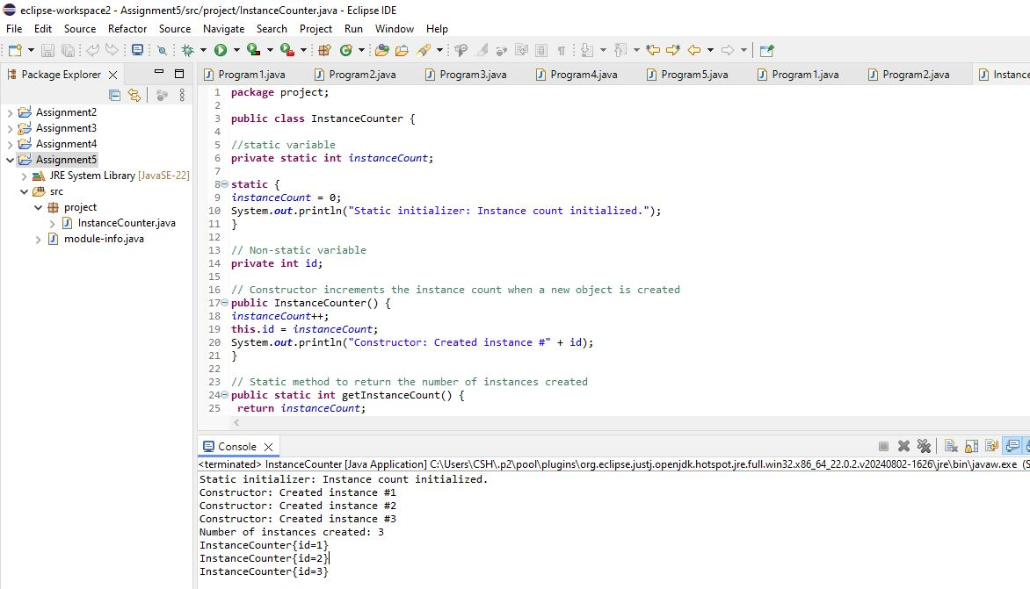

1. Design and implement a class named Employee to manage employee data for a company. The class should include fields to keep track of the total number of employees and the total salary expense, as well as individual employee details such as their ID, name, and salary.

The class should have methods to:

* Retrieve the total number of employees (getTotalEmployees())
* Apply a percentage raise to the salary of all employees (applyRaise(double percentage))
* Calculate the total salary expense, including any raises (calculateTotalSalaryExpense())
* Update the salary of an individual employee (updateSalary(double newSalary))

Understand the problem statement and use static and non-static fields and methods appropriately. Implement static and non-static initializers, constructors, getter and setter methods, and a toString() method to handle the initialization and representation of employee data.

Write a menu-driven program in the main method to test the functionalities.

Code :-

**package** project;

**import** java.util.Scanner;

**public** **class** Employee {

// Static fields

**private** **static** **int** *totalEmployees* = 0;

**private** **static** **double** *totalSalaryExpense* = 0.0;

// Non-static fields

**private** **int** employeeId;

**private** String name;

**private** **double** salary;

**static** {

System.***out***.println("Employee management system started...");

}

// Constructor

**public** Employee(**int** employeeId, String name, **double** salary) {

**this**.employeeId = employeeId;

**this**.name = name;

**this**.salary = salary;

*totalEmployees*++;

*totalSalaryExpense* += salary;

}

// Getters and Setters

**public** **int** getEmployeeId() {

**return** employeeId;

}

**public** **void** setEmployeeId(**int** employeeId) {

**this**.employeeId = employeeId;

}

**public** String getName() {

**return** name;

}

**public** **void** setName(String name) {

**this**.name = name;

}

**public** **double** getSalary() {

**return** salary;

}

**public** **void** setSalary(**double** salary) {

*totalSalaryExpense* -= **this**.salary; // Subtract current salary

**this**.salary = salary;

*totalSalaryExpense* += salary; // Add new salary

}

// Static method

**public** **static** **int** getTotalEmployees() {

**return** *totalEmployees*;

}

**public** **static** **void** applyRaise(Employee[] employees, **double** percentage) {

**for** (Employee emp : employees) {

**double** newSalary = emp.salary + (emp.salary * percentage / 100);

emp.setSalary(newSalary); // Update the employee's salary

}

}

// to calculate the total salary

**public** **static** **double** calculateTotalSalaryExpense() {

**return** *totalSalaryExpense*;

}

**public** String toString() {

**return** "Employee ID: " + employeeId + ", Name: " + name + ", Salary: $" + salary;

}

**public** **static** **void** main(String[] args) {

Scanner scanner = **new** Scanner(System.***in***);

Employee[] employees = **new** Employee[3];

employees[0] = **new** Employee(1, "shruti", 50000);

employees[1] = **new** Employee(2, "siddhi", 60000);

employees[2] = **new** Employee(3, "sanika", 70000);

**while** (**true**) {

System.***out***.println("\nEmployee Management System Menu:");

System.***out***.println("1. Display All Employees");

System.***out***.println("2. Apply Raise to All Employees");

System.***out***.println("3. Display Total Employees");

System.***out***.println("4. Display Total Salary Expense");

System.***out***.println("5. Update an Employee's Salary");

System.***out***.println("6. Exit");

System.***out***.print("Choose an option: ");

**int** choice = scanner.nextInt();

}

}

}

Output

